
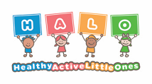


Healthy Active Little Ones
Healthy Eating

Table of Contents
(Please ctrl + click the contents to navigate the document)
Checklists 3
HALO East Sussex Lunch Box Audit 4
Activity Ideas 5
Cress seeds 6
Fruity yoghurt pots 7
Growing tomatoes 8
Pitta Pizza Faces 9
Feed the monsters 11
Rainbow shopping 12
Story sack ideas 14
Example letter to parents 15
Dora’s eggs 17
Eat your peas 18
Handa’s Surprise 19
Pumpkin soup 20
Which Food will you choose? 21
Book Ideas 22
Books not currently available at the ESCC library 30
Useful links and information 32
Recipes 32
Guidance 32
General Information 32
Training 33

Checklists
- EBSB full checklist
- EBSB checklist - food provision only
- Let’s get cooking - Hygiene and food safety checklist
- Safer food better business
- Allergen matrix


HALO East Sussex Lunch Box Audit
(To be used to evaluate before and after a lunchbox intervention)
A healthy lunchbox should always include one portion from the following healthy food groups. Starchy foods, protein, dairy, fruit and vegetables. Foods and drinks high in saturated fat, sugar or salt should be limited. As they can increase the risk of some illnesses in later life and can damage children’s teeth.
Use this evaluation tool to establish how many of the lunchboxes in your setting are balanced and nutritious. You might want to complete this both before and after an intervention.
You can look in each child’s lunchbox and record the number of items in each food group and write down each food item. You can involve children in this activity asking children to put their hands up if they have certain food items in their lunchbox.
Please email your HALO coordinator or the HALO group mailbox at healthyactivelittleones@eastsussex.gov.uk and they can send you a copy of this document.

Activity Ideas
Please use these HALO activity ideas in your settings and share with families for ideas to do at home.
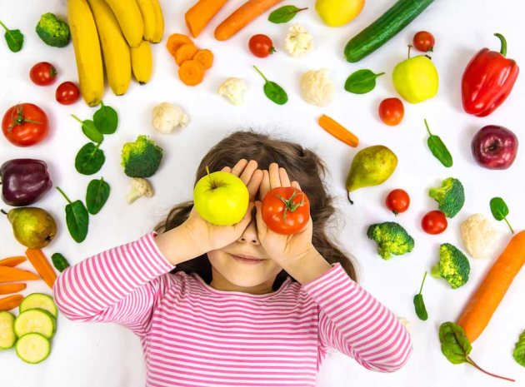

Cress seeds
Activity:
Step one: put a handful of cotton wool in the pot – enough to almost fill to the top.
Step two: evenly spread some cress seeds on top of the cotton wool and press them down gently (you can add some food colouring to the cotton wool if you want the cress ‘hair’ to be a different colour).
Step three: water the cress seeds.
Step four: put the pot in a warm place that gets some sunlight, like a windowsill.
Step five: watch the cress grow. This should happen after about seven days. You can cut the tops off the cress and sprinkle on top of your meal.
Resources:
- Cotton wool
- Cress seeds

Skills to develop:
- Knowledge of the world and where food comes from
- Fine motor skills

You could extend this by:
Creating other recipes with your cress. You could also grow different vegetables, fruit and herbs.
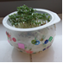

Fruity yoghurt pots
Activity:
Add a variety of tinned, frozen, or fresh fruit to a pot. Stir in yogurt and sprinkle some cereal or oats on top. You can even create layers if you’re feeling adventurous.
Resources:
- Pot
- Spoon
- Yogurt
- Oats
- Fruit
Skills to develop:
- Chopping
- Measuring (mathematics)
- Mixing
- Tidy away – independence
You could extend this by:
This cooking activity can be made in minutes and has endless variations, try using different fruits and exploring colour variations.
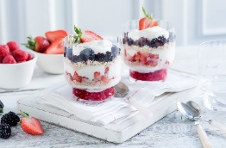

Growing tomatoes
Activity:
- Take each egg in turn and slice off the top third.
- Empty the shell – put yolks and whites aside to use in cooking.
- Make a small hole at the base of each eggshell and egg box section.
- Fill eggshells with compost and press down very lightly – put them in the box.
- Slice the tomatoes and capture all the seeds.
- Carefully spread the tomato seeds evenly on top of the compost.
- Spray the seeds with water – don’t drown them.
- Leave the egg box somewhere nice and light – but not in direct sunlight, you will soon see little green shoots emerge.
- Lift each eggshell out of the box. Squash the shell and transfer to a bigger pot.
Resources:
- A carboard egg box; six eggs
- Three medium tomatoes
- A small bag of potting compost
Skills to develop:
- Understanding where food comes from
- Fine motor
You could extend this by:
Exploring the seeds and pips of different fruits and vegetables and seeing what else you can grow from a seed. Comparing differences between seeds.
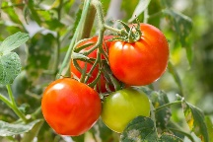

Pitta Pizza Faces
Activity:
- Preheat the grill or, if you prefer, cook these in an oven preheated to 180 degrees Celsius, fan oven at 160 degrees Celsius or gas mark four for eight to ten minutes.
- Spread the tomato puree over one side of each pitta bread.
- Sprinkle with the dried mixed herbs
- Arrange cucumber and tomatoes on the pittas to resemble facial features.
- Place on the grill rack
- Grill for four to five minutes.
- Cool for a few moments and serve.
- Enjoy
Resources:
- Four wholemeal pitta breads
- Four teaspoons of tomato puree
- One teaspoon of dried mixed herbs
- Eight thin cucumber slices
- Six cherry tomatoes, halved.
- One yellow or red pepper, deseeded and sliced crossways
- 40 grams of grated cheese
- Baking sheet
Skills to develop:
- Chopping
- Spreading
- Mathematics, taking about halves and quarters.
- Oven safety

You could extend this by:
Discussing the faces and facial features, does it look like anyone? Discussing similarities and differences. Discussing the foods, you have added to the pizzas and how these keep our bodies healthy.
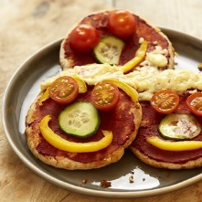
Feed the monsters.
Activity:
- Use an empty tissue box and decorate it to create a monster.
- When made, use something small such as pom-poms or ping-pong balls to ‘feed’ the monster by throwing the balls into its mouth.
- Attach pictures of different food items to your balls and throw them into the monster’s mouth. The person with the healthiest food in their monster’s mouth is the winner.
Resources:
- Tissue box
- Items to decorate your monster (could be pens or paints)
- Pom poms / ping pong balls
- Pictures of a variety of foods
Skills to develop:
- Learning about healthy lifestyles
- Gross motor skills
- Hand eye coordination
You could extend this by:
Using this opportunity to talk about foods that are healthy and unhealthy. Encouraging children to only feed the monster healthy foods. How about avoiding foods that are bad for the monsters’ teeth?
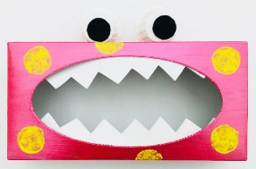

Rainbow shopping
Activity:
- Read the book “Which Food Will You Choose”.
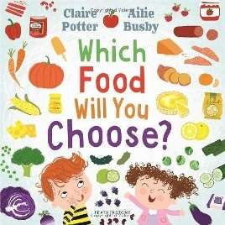
- On each colour page talk about what foods are yours and their favourites of each colour (this can either be done as one colour a week e.g., this week its ‘red’ OR you could choose one thing from each colour).
- Use an eat a rainbow for a simple shopping list next time you go shopping with a child, encourage them to pick something from each colour.
Resources:
- Book “Which Food Will You Choose”
- Shopping list picture (printable from the above embedded document)
Skills to develop:
- Learning about different food groups and healthy foods
- Language skills
You could extend this by:
- Taking a trip to the library to borrow and read similar books to embed knowledge (e.g. “I can eat a Rainbow” by Olena Rose or “Olivers Fruit Salad” by Vivian French)
- Cooking a yummy snack or meal with the rainbow foods you bought.
- Mixing colours to create new ones.
- Creating paints from your coloured fruit and vegetables.
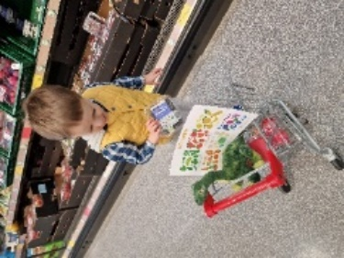
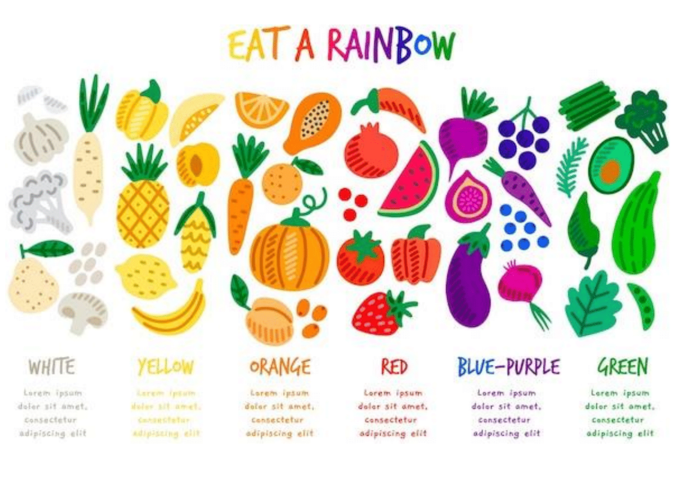

Story sack ideas
Please use these HALO ideas to help create story sacks and take-home bags in your setting to share with families. Use our example letter to send home with parents to support them in using the bags.

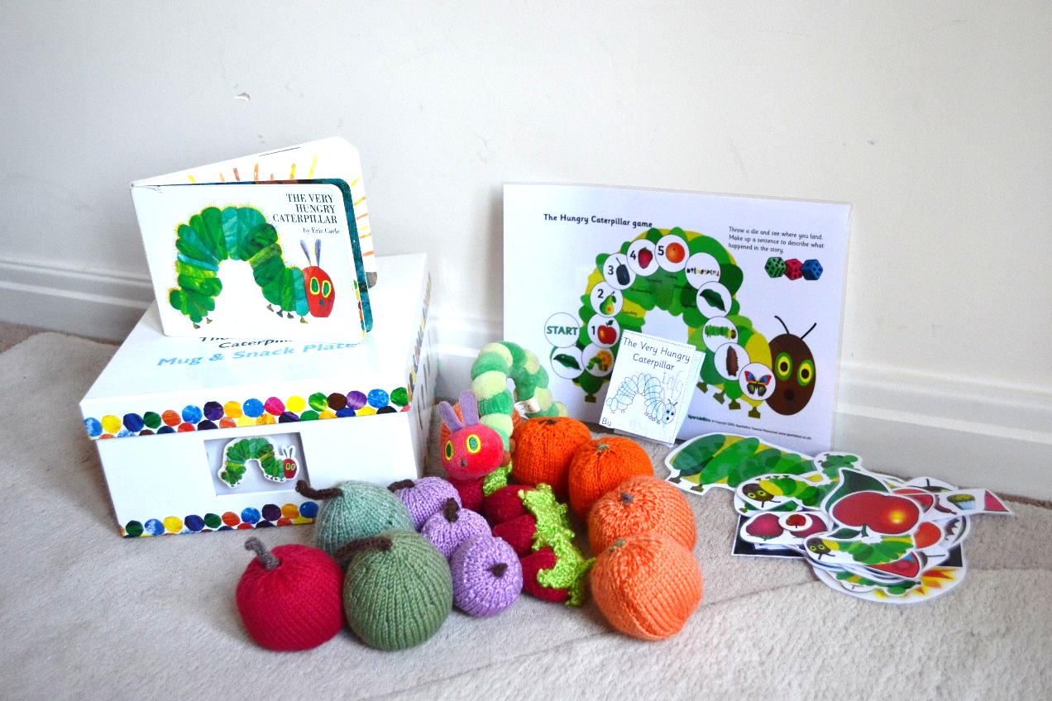

Example letter to parents
Dear parents/carers,

This week it is your child’s turn to bring home one of our cookery bags. This is an exciting initiative to increase opportunities for children to learn about basic cookery skills together with their families at home, try new foods and textures, and promote recipes for healthy and balanced meals and snacks. Your child will be given the cookery bag to keep at home for XXX.

As well as recipes, stories, and utensils you will also find a small notebook for you or your child to capture the experience. This could be accompanied by a photo of the finished result, or a picture drawn by your child.

The cookery bag consists of the following items:
- Contents list
- A story book to read together.
- Recipes for you and your child to try out.
- A Food Hygiene and Safety c checklist.
- A notebook – for recording how you get on.
- Simple food utensils – for you to use in the recipes.
There are some great online videos to help with specific cooking techniques (such as safe chopping and peeling)! Videos - Let's Get Cooking at HomeLet's Get Cooking at Home (letsgetcooking.org.uk)

Please ensure that you always supervise your child as part of cooking activities and when using any sharp items such as peelers. Please ensure that you cut small and large fruits into small chunks to reduce risk of choking, and that all fruit and vegetables are washed thoroughly before use.

It would be much appreciated if you could wash and return all the items provided in the cookery bag (there’s a handy list for you to check that everything is there) on the specified day so that other children can have a chance to enjoy it.

Please leave a comment in the notebook about how the cookery time went and try to include a photo of the fun you have.

We very much hope you have fun using the cookery bags and look forward to hearing about how you get on.

Dora’s Eggs
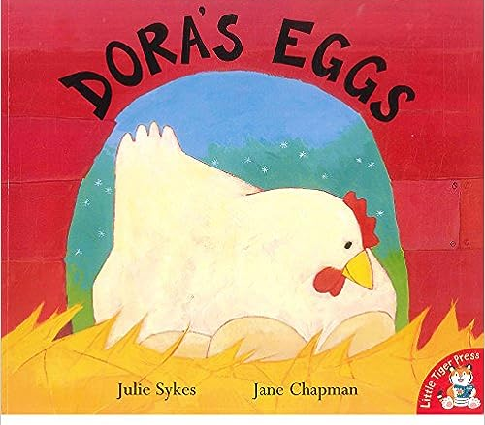
Egg-cited for eggs? Eggs are a great source of protein, and you can use them in all sorts of different types of meals. We’ve picked out our favourite egg-ceedingly good recipes for you to have a crack at.
Contents:
Book - Dora’s Eggs by Julie Sykes
A baking tin.
A whisk
A grater
A letter with instructions for home.
A notebook and pen.

Recipes:
Omelette popovers
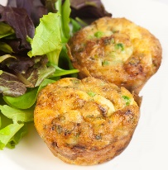
Scrumptious scrambled eggs
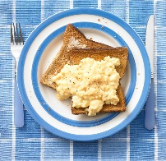

Eat your Peas
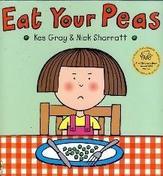
Are you struggling to make vegetables exciting? Try some of these easy tasty recipes which will leave your family asking for more.
Try to include as many different coloured vegetables as you can. Use up all your leftover vegetables to reduce food waste.
Contents:
Book - ‘Eat your Peas’ by Kes Gray and Nick Sharratt
A vegetable peeler
A letter with instructions for home.
A notebook and pen.
Recipes
Vegetable soup
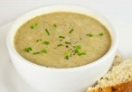
Traffic light rice
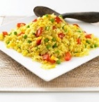
Cheesy vegetable crumble
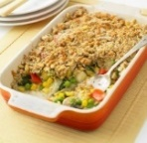

Handa’s Surprise
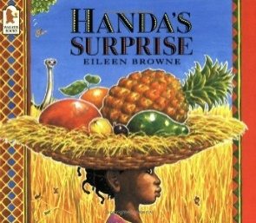
Here are some of our favourite luscious fruity recipes, helping you reach your five-a-day and cut down on high sugar desserts.
Contents
Book - Handa’s Surprise by Eileen Browne
Tin Opener and skewers.
A letter with instructions for home.
A notebook and pen.
Recipes
Tropical fruit salad
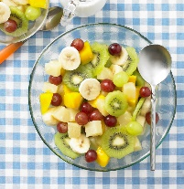
Fruit kebabs
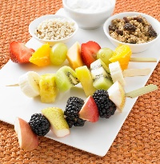
Baked apples
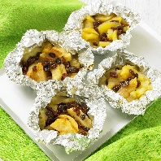

Pumpkin Soup
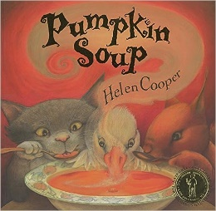
Eating food that is in season is cheaper and extra nutritious. Autumn is a great time for warm comforting food, and a time where there is a lot of pumpkins and squash around, but how do you cook them?
Contents
‘Pumpkin Soup’ by Helen Cooper
A vegetable peeler
Hand blender
Muffin tin (12 holes)
A letter with instructions for home.
A notebook and pen.

Recipes
Pumpkin soup
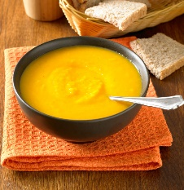
Autumn muffins
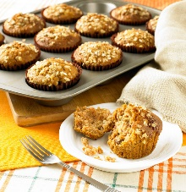

Which Food will you Choose?
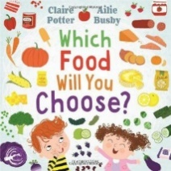
Get the children involved in shopping and choosing healthy produce by encouraging them to choose foods that are each colour of the rainbow.
Contents:
- Book – Which Food will you Choose? by Claire Potter
- Shopping game
- Letter home
- Notebook
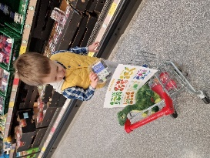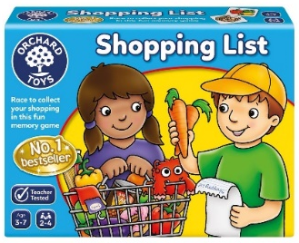
Recipes:
Rainbow Fruit Skewers
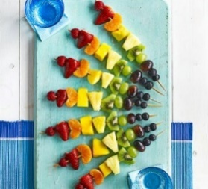

Book Ideas
All these book suggestions are available to borrow for free when you sign up to the East Sussex Library service.
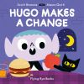
Name: Hugo Makes a Change
Author: Scott Emmons and Mauro Gatti
ISBN: 978—1-911171-21-8 Age: 3+
About:
Hugo the vampire craves red meat for every meal. But when his eating habits leave him feeling sluggish and bored, he goes on the prowl for something new...
After trying fruits and vegetables for the first time, he discovers the joys of a more balanced diet.
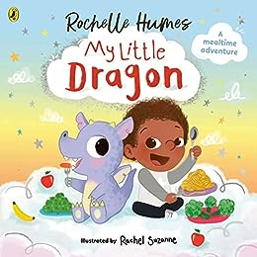
Name: My Little Dragon
Author: Rochelle Humes
ISBN: 978- 0241586518 Age: 2-4
About:
Blake's mum and dad have NO IDEA that he lives with lots of magical creatures. There's the unicorn in his wardrobe, the octopus in the bath and his VERY hungry little dragon. Will Blake be able to find the perfect treat to help his fussy little dragon fly?
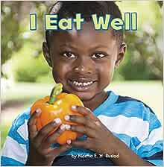
Name: I eat Well
Author: Martha, Rustad
ISBN: 978-1474734851 Age: 4-7
About:
Learning to eat healthily is a tough job. Carefully levelled text allows the youngest readers to read independently and learn all about eating well.

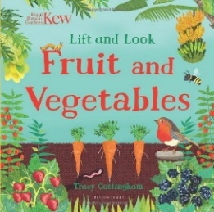
Name: Fruit and Vegetables
Author: Tracy Cottingham
ISBN: 978-1526636836 Age: 0-5
About:
How many places can fruit, and vegetables grow?
Lift the flaps to see what is inside. From leafy green vegetables to colourful tropical fruit and jewel-like berries, there is lots to discover on every page.
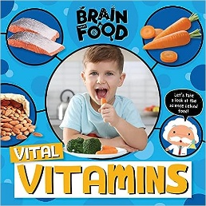
Name: Vital Vitamins
Author: John Wood
ISBN: 978-1839274862 Age: 3+
About:
You know that food is important. But do you know why? What really happens if you don’t eat your vegetables? How do carbs affect your brain? How does chocolate change your body? This book explores the science behind food.
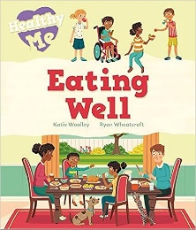
Name: Eating Well
Author: Katie Woolley
ISBN: 978-1526305589 Age: 5+
About: Why should I eat fruit and vegetables? What's wrong with chocolate and crisps? What are proteins and carbohydrates? The answers to these and many other questions about healthy eating can be discovered in this lively and informative book. This book is designed for children to begin to learn about the importance of being healthy.
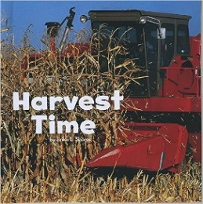
Name: Harvest Time
Author: Erika L. Shores
ISBN: 978-1474702966 Age: 4-8
About:
Corn ripens in the fields. Garden vegetables are ready to pick. Autumn is here. Celebrate the season with this easy-to-read book.
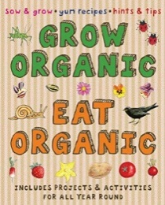
Name: Grow Organic, Eat Organic
Author: Lone Morton
ISBN: 9781908164650 Age: 4-12
About:
Starting your own family vegetable patch at home is a great way to eat healthily. It’s always exciting to cultivate your own plants, whether in pots, window-boxes or in the garden. This outdoor activity helps soothe anxiety and calm the minds of your busy family members. Discover lots of useful advice in this lovely book for budding gardeners and cooks. Includes clear step-by-step approach to sowing, cooking, and eating in harmony with the natural world.
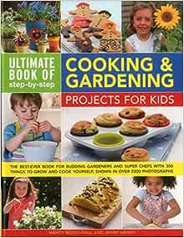
Name: 300 Step-by-step cooking and gardening projects for kid.
Author: Nancy McDougall
ISBN: 9781861477071 Age: 3+
About:
Children love to get their hands dirty, and this book is packed with 300 exciting projects that will keep them entertained in both the kitchen and the garden.
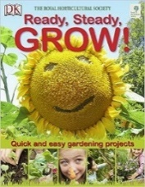
Name: Ready Steady, Grow!
Author: Royal Horticultural Society
ISBN: 978-1405352383 Age: 4+
About:
Get your child in the garden. Get sowing and harvesting and they will learn to grow all kinds of plants, vegetables, and fruits quickly and easily.
No need to wait months for results: they'll be able to follow the simple instructions to raise fantastic plants in twelve weeks or less. Soon they'll have tasty tomatoes and delicious strawberries and sprouting seeds ready to eat in a week. There are fun projects, too: from making a pizza garden and growing a fairy ring, to designing a wildlife window box. You don't even need a garden: there are lots of ideas for using containers, baskets, and boxes.
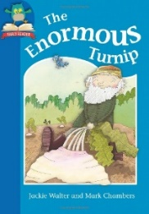
Name: The enormous turnip
Author: Jackie Walter
ISBN: 978-1445144405 Age: 4+
About:
The farmer has grown the most enormous turnip in the world. Will he and his friends ever be able to pull it out of the ground?
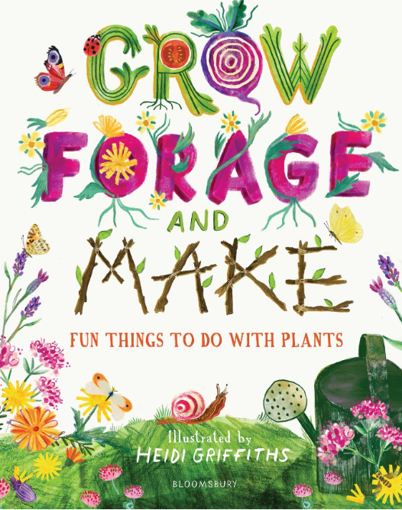
Name: Grow, Forage and Make
Author: Alys Fowler
ISBN: 978-1526619105 Age: 4+
About:
From growing your own air plants to foraging for edible flowers, this book will take you through a range of indoor and outdoor activities to ignite a lifelong passion for plants. You don't need a garden or any fancy equipment. With expert guidance you can grow your own avocado tree, make wildflower seed paper, forage for tasty roots to add to your favourite recipes and even grow neon pink beetroot in the dark.
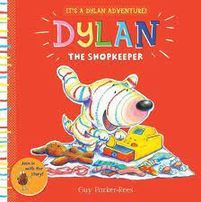
Name: Dylan the Shopkeeper
Author: Guy Parker-Rees
ISBN: 978-1407166285 Age: 1+
About:
Dylan is a joyous new character who uses playing and fun to help toddlers explore and understand their world. Today Dylan is playing at being a shopkeeper. It's all great fun, until his friends, Jolly Otter and Purple Puss, decide they want to be shopkeepers, too.
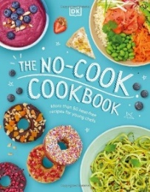
Name: The NO-COOK cookbook
Author: Rebecca Woollard
ISBN: 978-0241459539 Age: 4+
About:
More than 50 recipes for young food lovers. Teach children how to create tasty meals without heat. This cookbook will show children how to cook all by themselves and gain their independence in the kitchen. Each recipe is designed so that it's easy to make and requires no cooking.

Books not currently available at the ESCC library
These are book suggestions which are not currently available to borrow from the East Sussex Library service.
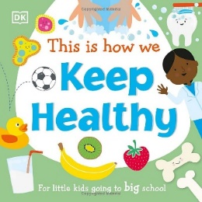
Name: This is how we keep Healthy
Author: DK Publishers
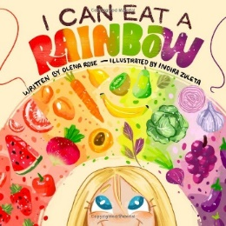
Name: I can eat the Rainbow
Author: Olena Rose
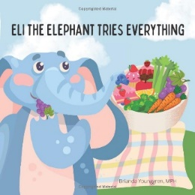
Name: Eli the Elephant tries everything
Author: Brianda Younggren

Useful links and information

Recipes
- Healthy Recipes from HENRY
- Change for life recipes
- Lets get cooking recipes
- Phunky foods recipes
- Lets get cooking recipes - BBC good food
- Early start recipes - Including themed recipes for different celebrations.
- BDA recipes

Guidance
- Gov UK: Sensory food education - Help for early years providers
- Gov UK: Example menus for early years settings in England
- Gov UK: Food safety for early years providers
- Food standards agency: Choking advice table
- Food Foundations: Peas-Please-Veg-Facts-2021.pdf (foodfoundation.org.uk)

General Information
- Eat Better, Start Better – Voluntary Food and Drink Guidelines for Early Years Settings in England
- Example early years menus guidance and Recipes
- Producing and sharing allergen information
- Healthy Start
- How to introduce solid foods Weaning | Start 4 Life (www.nhs.uk)
- Eating well resources from First Steps Nutrition Trust
- Cookery and food activities as a context for development and learning in the EYFS
- Information on batch cooking and freezing
- Foundation years = Healthy eating and safe food preparation
- Sensory food education What is TastEd? | Taste Education
- East Sussex Family Hubs

Training
The Healthy Active Little Ones team offer two training sessions in this topic.
Healthy foods
The aims of this session are:
- To develop practitioners’ knowledge of what a healthy lunchbox consists of and shed light on unhealthy lunchbox practices, providing facts to conquer myths.
- To develop and share healthy lunchbox ideas.
- To support practitioners to share information on healthy foods with families.
- To develop practitioners’ confidence to cascade the skills, knowledge, and confidence to cook from scratch.
- To support practitioners to develop the ability to plan and deliver a cooking course for families.
- To develop knowledge of the latest updates in the Voluntary Food and Drink Guidelines for Early Years Settings – specifically the newly introduced desserts guidance.
- To apply the Voluntary Food and Drink Guidelines for early years settings to menu planning for desserts.

Infant feeding
The aims of this session are:
- To enhance knowledge on safe storage, heating and handling of breast milk and formula milk.
- To provide practitioners with the knowledge they need to support and advise parents.
- To explore methods of introducing solid foods.
- To explore responsive feeding values.
To book your setting onto either of these training sessions contact the HALO team. They will be able to find available dates and book you a space.
Email: Healthyactivelittleones@eastsussex.gov.uk

